**Diferenta de timp dintre o procedura cu NOCOPY si una fara, pe o colectie mare**

Mai intai am creat o tabela cu 10 milioane de randuri:

CREATE TABLE large_table (

id NUMBER,

name VARCHAR2(100),

description VARCHAR2(500)

);

INSERT INTO large_table

SELECT LEVEL, 'Name ' || LEVEL, 'Description ' || LEVEL

FROM dual

CONNECT BY LEVEL <= 10000000;

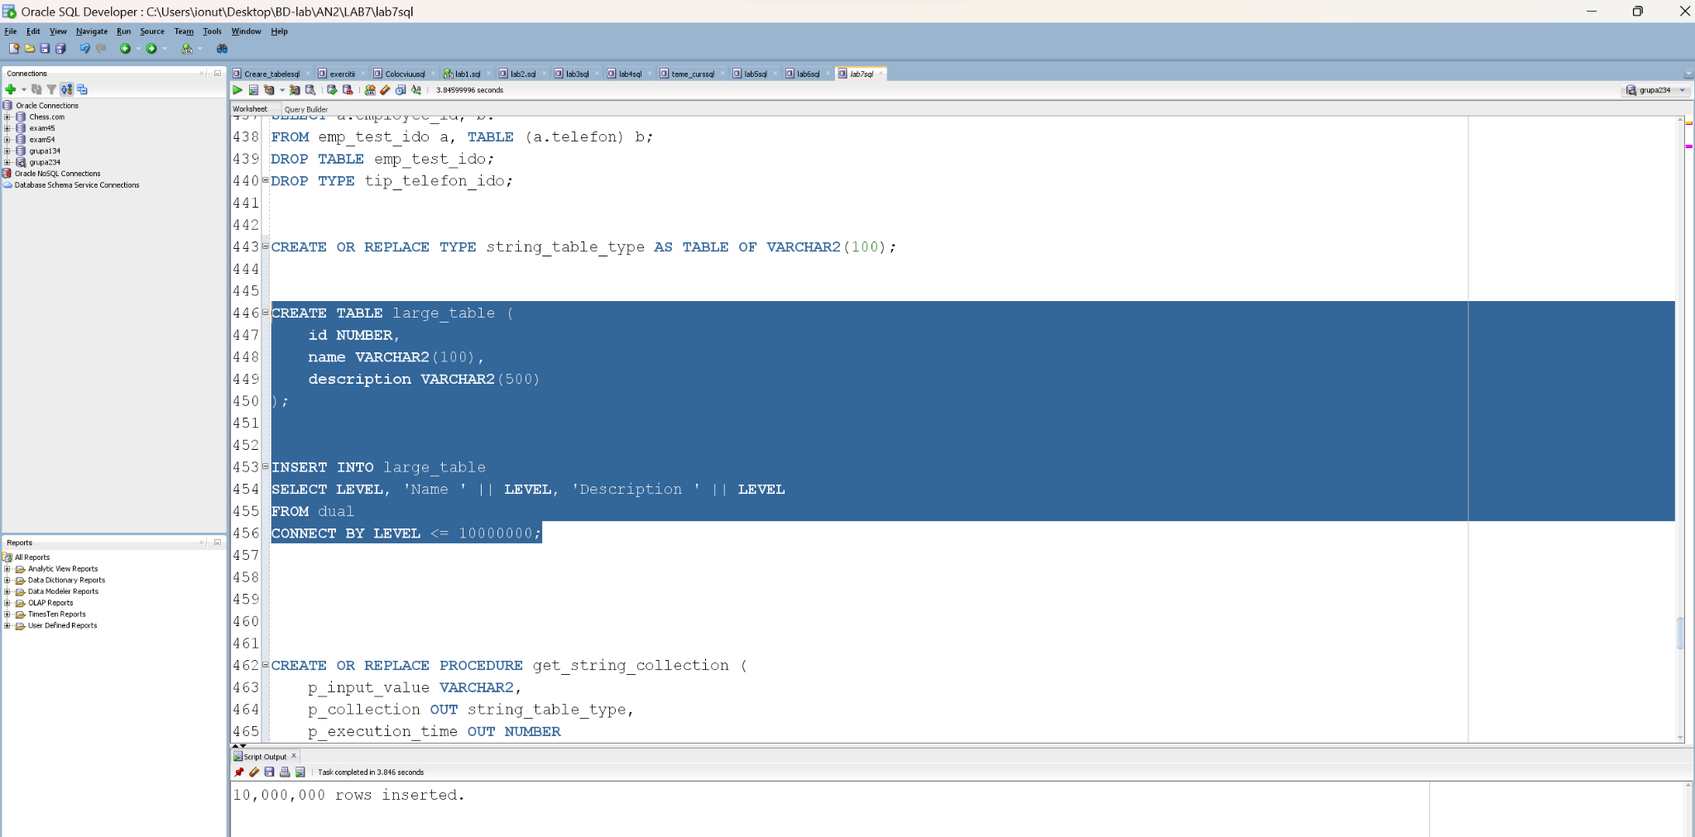

Dupa aceea am creat o procedura fara NOCOPY.  
  
CREATE OR REPLACE PROCEDURE get_string_collection (

p_input_value VARCHAR2,

p_collection OUT string_table_type,

p_execution_time OUT NUMBER

) IS

v_start_time TIMESTAMP;

v_end_time TIMESTAMP;

BEGIN

v_start_time := SYSTIMESTAMP;

SELECT name

BULK COLLECT INTO p_collection

FROM large_table

WHERE description = p_input_value;

v_end_time := SYSTIMESTAMP;

p_execution_time := EXTRACT(SECOND FROM (v_end_time - v_start_time));

EXCEPTION

WHEN OTHERS THEN

NULL;

END get_string_collection;

/

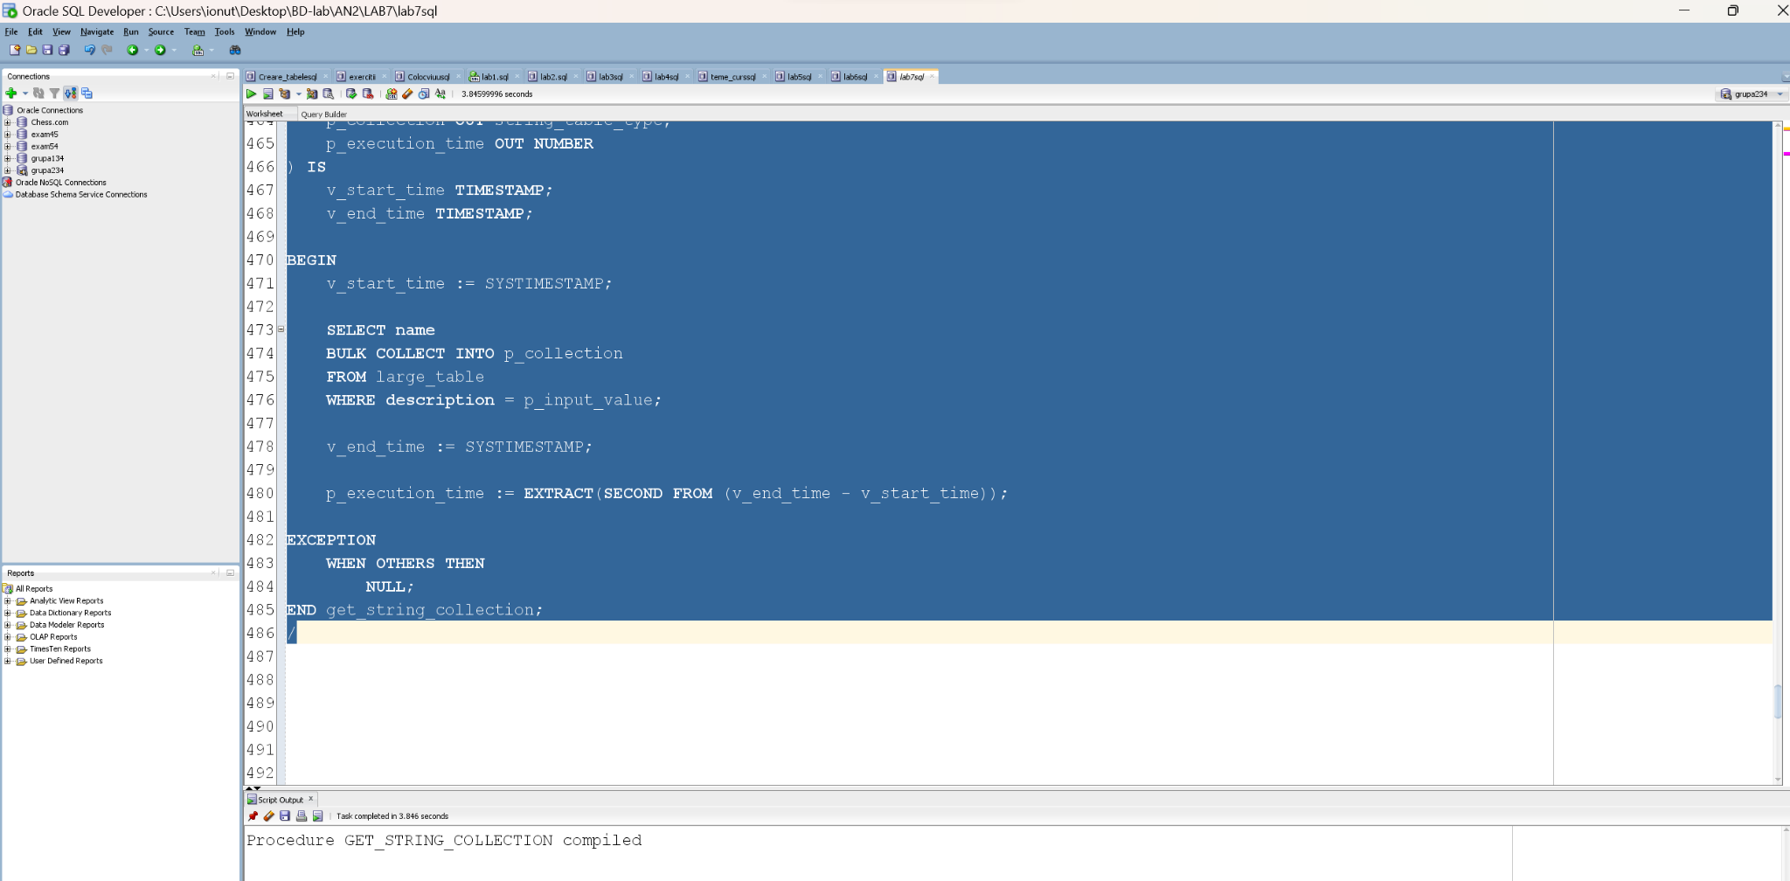

Am creat si procedura cu NOCOPY.

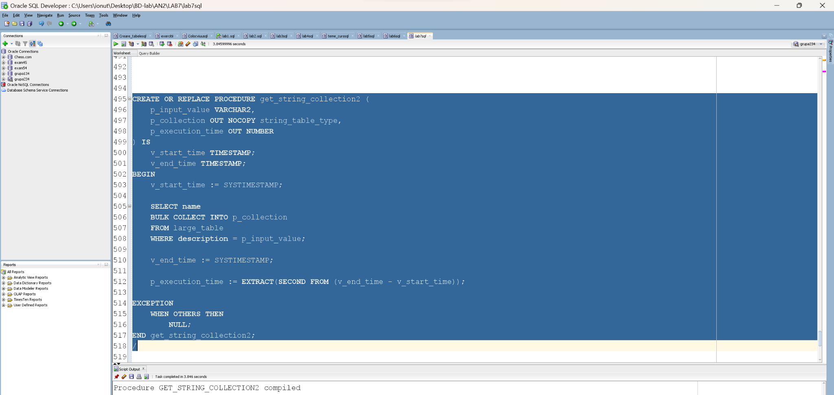

Aceste proceduri masoara si timpul de executie.

In final, le-am comparat, apelandu-le pe ambele in acelasi bloc de executie:

DECLARE

my_collection1 string_table_type;

execution_time1 NUMBER;

my_collection2 string_table_type;

execution_time2 NUMBER;

BEGIN

-- Measure time for get_string_collection

get_string_collection('Description 1', my_collection1, execution_time1);

DBMS_OUTPUT.PUT_LINE('Execution Time for get_string_collection: ' || execution_time1 || ' seconds');

-- Measure time for get_string_collection2 with NOCOPY

get_string_collection2('Description 1', my_collection2, execution_time2);

DBMS_OUTPUT.PUT_LINE('Execution Time for get_string_collection2 with NOCOPY: ' || execution_time2 || ' seconds');

END;

/

Unde string_table_type este:

CREATE OR REPLACE TYPE string_table_type AS TABLE OF VARCHAR2(100);

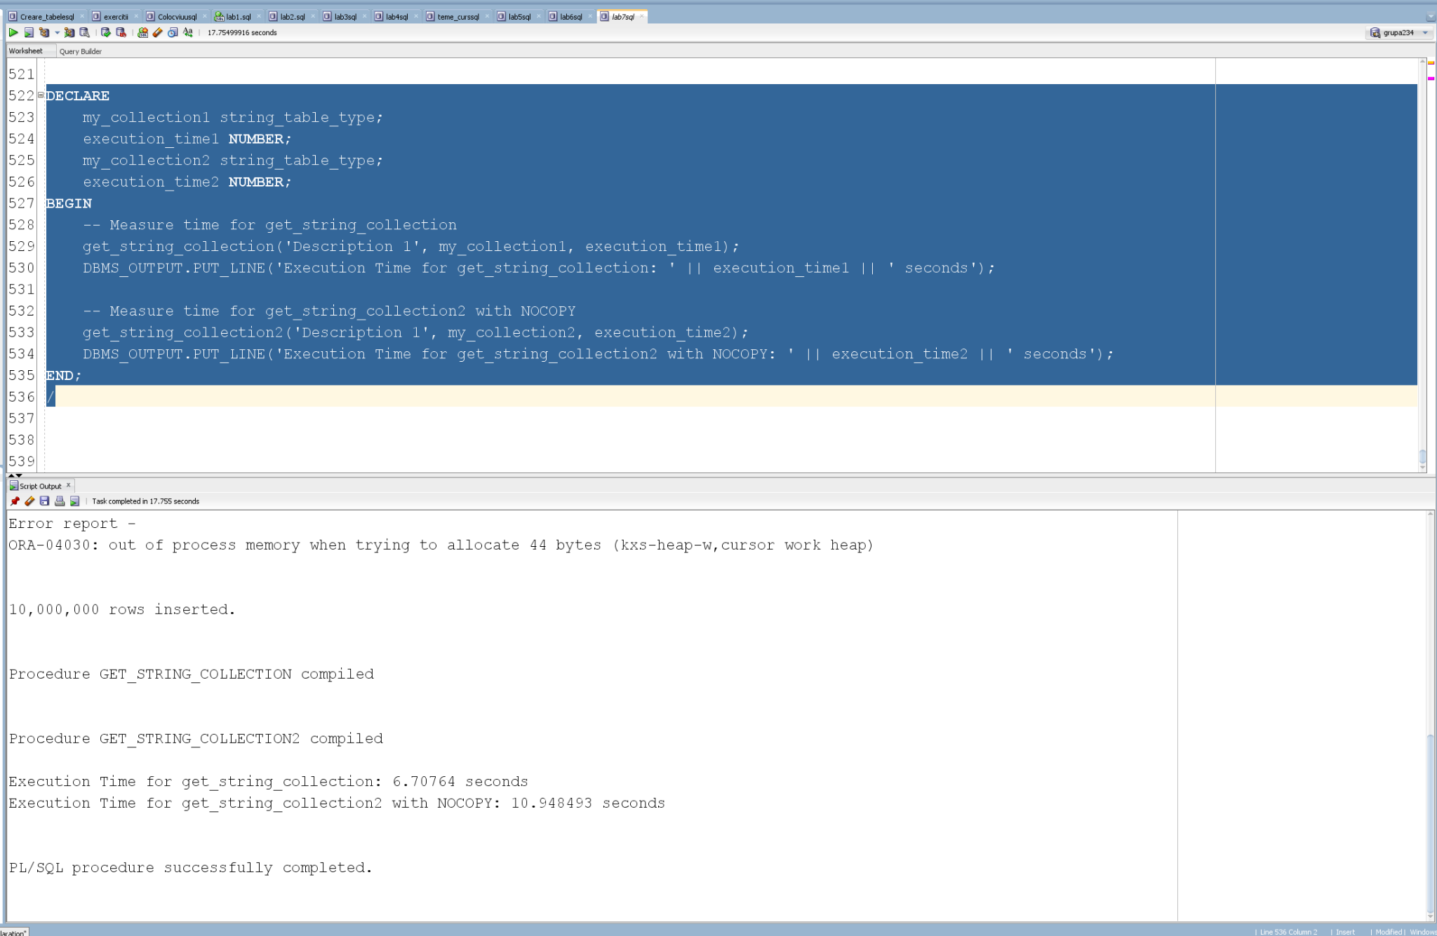

**Concluzie:**

Asadar, conform testului pe care l-am efectuat, varianta fara NOCOPY a rulat mai rapid, si se observa o diferenta semnificativa pentru timpul de rulare pe o colectie cu multe date.